Mpd design document

John Reid S1511280

# Introduction

When designing the app to display earthquake information, Neilson’s 5 laws of usability were followed to ensure that the app was designed correctly, and that the app had solid usability. Neilson’s 5 laws of usability are as follows:

1. Learnability
2. Efficiency
3. Memorability
4. Errors
5. Satisfaction

Throughout this report each of these laws will be discussed and an explanation of how the design of the app revolved around each of these laws.

# Learnability

According to Neilson the first law which is learnability is defined by how easy it is for users to accomplish basic tasks the first time they encounter the design? With this in mind it was important that the initial layout of the app was relatively simple and clear.

## Initial App Layout

When designing the initial layout of the app it was clear that it wasn’t possible to display all of the earthquake information at once so it had to be made which earthquake the user wanted to find and then display the rest of the information when they clicked on the earthquake. Initially only the location of the earthquake and the date the earthquake occurred would be displayed as it allows the user to easily identify which location the earthquake occurred and the date that it occurred to ensure that they were researching the correct one. There will also be a button below the date that states “more info…” to imply to the user that if they click on the button more information about that specific earthquake will be displayed. This button will be larger so the user can clearly see that it’s there and is easily clickable. The app has been designed in this way to reduce clutter in the main app, it will display the core information that the user needs to know and if an more info button is clicked on a separate window will display the rest of the information.

A search bar will be set at the top of the screen to allow the user to search for specific earthquakes or specific magnitudes or depth etc. Next to the search bar will be a sort button with the sort logo on it and when pressed a popup menu will display all the variables the earthquakes can be sorted by. The search bar and sort button will be placed at the top of the screen as when researching standard app layouts, it’s standard practice to place these at the top of the screen so they are easily accessible to the user.

## Colour Scheme

The colour scheme of the app can also be used to improve the learnability of the app as it can be used to point towards important information that the user can use. Before a colour scheme was selected some guidelines were looked at so an appropriate colour scheme could be selected. The first guideline that was looked at was keeping the colour scheme simple so that it does not overwhelm the user as having too many colours on the screen may confuse the user which would not benefit the overall experience. From that guideline it was decided that the colour scheme of the app would only be 2 colours as it would not overwhelm the user and one colour could be used to highlight important information and the other colour could be used as the background colour. The second wasn’t so much a guideline but a selection of colour schemes that would match each other. Since only 2 colours are being used it seemed best to go for a contrasting colour scheme so the user could easily identify the important information. A contrasting colour scheme is also beneficial as it will allow users who suffer from low vision, colour blindness and worsening vision to easily read the test so long as the contrast between the two colours is high enough. Small text should have at least a 4.51:1 contrast ratio against its background and large text should have a ratio of at least 3:1 against its background. With all of this in mind it was decided that the two colours used would be a mustard yellow (#F9C61D) and a greyish black (#3B3B3B) would be used as they contrast with each other and when put into a contrast comparer it had a contrast ratio of 7:1 which passed all the test when it comes to visual impairment so everyone should be able to clearly see the important text on the screen.

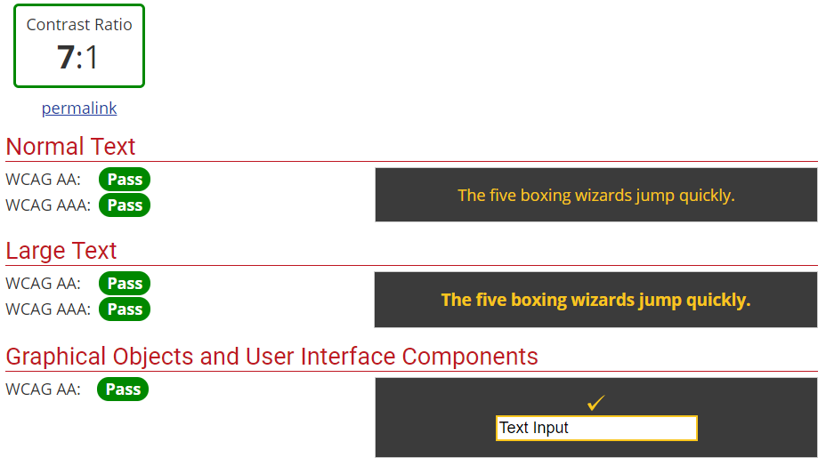

Now that the initial layout of the app has been designed and discussed the next step of Neilson’s laws of usability must be looked at.

# Efficiency

Neilson’s definition of this law is “Once the user has learned the design, how quickly can they perform tasks”. Since the overall design of the app is a simple one the overall efficiency per user should be relatively high. The user should be able to clearly identify which earthquake they are looking for, determine that they need to click on the button for more information, be able to search for specific earthquakes and sort the earthquakes depending on the variable they want. However, just saying that it should be efficient doesn’t necessarily mean that it is going to be. This means that for this law to be followed correctly testing on users must be done. The colour scheme was also selected to promote efficiency. Since the colour scheme contrasts it should be clear to the user what they can interact with and should be quickly picked up what the user can and cannot do. This is why all the important information or anything that should be brought to the attention of the user is in yellow, so it catches their eye. The search bar and sort button at the top should also help promote efficiency. Since the search bar at the top is standard practice for most apps, the user should instantly recognise that it is a search bar and that they can use it to search for specific earthquakes or earthquakes with a specific variable (e.g. depth, magnitude). The sort button has been designed the same way, since it is next to the search bar which influences the list then the user should assume that the button will do something similar to the search bar and since the button has a sort icon on it they should be able to deduce that it is a sort button and it’s uses.

# Memorability

Neilson defined memorability as when users return to the design after not using it for a period of not using it, how easily can they re-establish proficiency Again, since the app has a minimalist layout there shouldn’t be any issues with remembering how to use the app after returning from a period of not using the app. When creating the minimalist design this law was taken into account, this is why there is a massive more info button under each earthquake so they can clearly see that the button is what you press if you want to see further information. This law was also taken into account when considering the colour scheme as the text that contrasts with the background will be the important information and when the user sees this again, they should easily remember that the contrasting text is important. Also, search earthquake will have a yellow outline around it to highlight that’s what the user should be looking at and interacting with.

# Errors

Neilson defined the Errors law as how many errors does the user make, how severe are these errors and how easily can they recover from these errors. This law is one of the most important laws as if a user finds it difficult to navigate through the page and keeps making mistakes, they will get frustrated and delete the app. When designing the app, due to it’s basic layout it was expected that the user wouldn’t make any errors. It seemed fairly obvious that the more info button displays more information and the search bar was used for searching. However, in order to combat any errors being made, there is easy recoverability from each of the interactions that the user can make. For example, if the user accidentally clicks on the wrong earthquake’s wrong info button, then the user can very easily click off the window displaying the extra information and it will take them back to the list of earthquakes. Even if the user has searched for a specific magnitude and accidentally presses on the wrong earthquake when they click off the list won’t reset back to normal so the user can continue from where they left off. The search bar also updates in real time so the user doesn’t need to complete the whole location for example which will save time and reduce errors when it comes to spelling mistakes. This will also work for the magnitude and depth of the earthquakes. The sort button shouldn’t have any errors but if the user accidentally clicks the wrong variable, they want to sort by then they can quite easily go back to the sort button and select the correct variable

# Satisfaction

Neilson defines satisfaction as how pleasant is it to use the design? This law in particular is probably the hardest law to cater for as satisfaction can differ from user to user. Some users may be satisfied while only using a fraction of the tools provided by the app whereas others may still be unsatisfied despite having a range of different tools that cover the full range of the app’s information. However, an attempt must be made to ensure that most of the users that use the app are satisfied. This again is why the search bar is placed where it is as it is easy to get to, why the information isn’t all displayed at once as it would appear cluttered and therefore decrease the satisfaction of the user as they are just presented by a wall of information. Again, why a contrasting colour scheme was selected to point the user in the direction of where to look and what to interact with. Satisfaction cannot be guaranteed with the design however so user testing will have to take place in order to ensure that the app is to a high satisfactory level